This is an example of Chapter 2 Project 2.

Review this program if you did not receive the maximum points for this assignment.

If you did not complete this assignment, use this to help you.

You may submit this assignment late for reduced point.

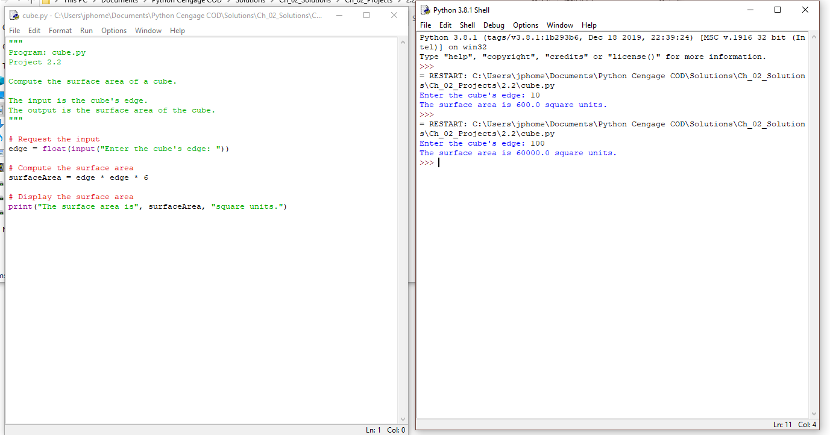

Mr. Powell